EZG18 - Haunted Castle – Proposal

# Story

We encounter us in a medieval dark room that seems to be haunted. Only light falls inside throw a small window and we can barely identify the objects around us. Suddenly torches catch fire as if by ghost hand. We take a look around the room and see different things moving: A chair that is moving forward, chess figure starting moving, torches move to an upright position and paintings falling down.

# Scene

Medieval room with torches on fire, knight armors, chairs with chess desk, stone walls, paintings and closet.

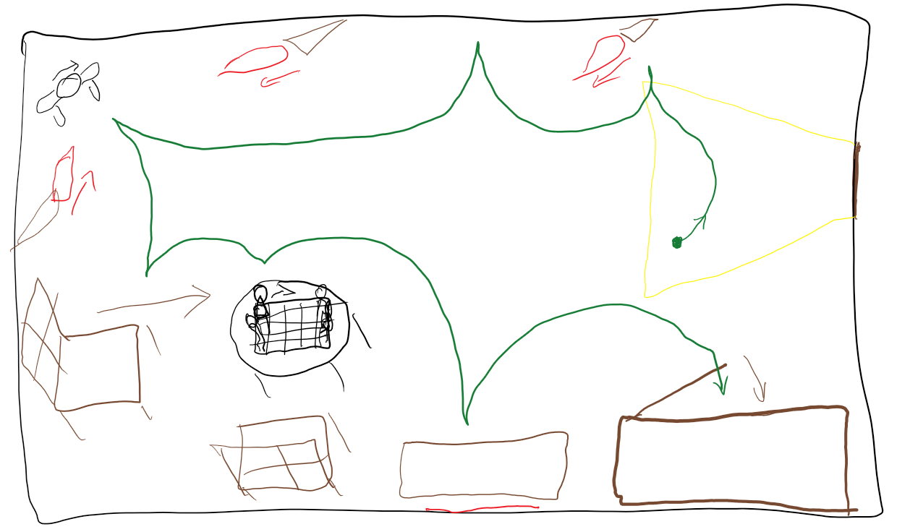

# Effects

* Shadow Mapping with PCF (all objects in scene)
* Fire with Particle Effect (applied on torch)
* Glow + Light Rays (Window)
* Bump Mapping (Stone Wall)

# Sources

* Shadow Mapping with PCF:  
  Liu, N., & Pang, M. Y. (2009, January). Shadow mapping algorithms: a complete survey. In Computer Network and Multimedia Technology, 2009. CNMT 2009. International Symposium on (pp. 1-5). IEEE.  
  <https://ieeexplore.ieee.org/stamp/stamp.jsp?tp=&arnumber=5374715>

Reeves, W. T., Salesin, D. H., & Cook, R. L. (1987, August). Rendering antialiased shadows with depth maps. In ACM Siggraph Computer Graphics (Vol. 21, No. 4, pp. 283-291).

<https://dl.acm.org/citation.cfm?id=37435>

* Fire with Particle Effect:  
  Reeves, W. T. (1983). Particle systems—a technique for modeling a class of fuzzy objects. ACM Transactions on Graphics (TOG), 2(2), 91-108.  
  <https://dl.acm.org/citation.cfm?id=357320>
* Glow + Light Rays:  
  <http://harkal.sylphis3d.com/2006/05/20/how-to-do-good-bloom-for-hdr-rendering/>
* Bump Mapping:  
  Kilgard, M. J. (2000, July). A practical and robust bump-mapping technique for today’s GPUs. In Game Developers Conference 2000 (pp. 1-39).  
  <https://www.cg.tuwien.ac.at/courses/Realtime/slides/VU.WS.2013/PracticalBumpMap.pdf>